LAB ASSIGNMENT 13.4

K. VIGNANAND RAO
2303A52439
BATCH 41

TASK 01: Refactoring Data Transformation Logic
PROMPT:
Refactored version of above code by using list comprehension or helper function by preserving the output.
CODE:
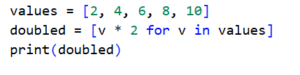
OUTPUT:
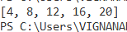
JUSTIFICATION:
In the above task we have refactored the given code by using list comprehension which is most used in these days. Even though the time complexity of both legacy code and refactored code is same, but refactored code is an advanced version of the legacy code.

TASK 02: Improving Text Processing Code Readability
PROMPT:
Refactor the above full code by adding the more readable and efficient approach.
CODE:
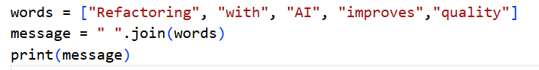
OUTPUT:
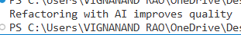
JUSTIFICATION:
In the above, in legacy code, we are using a for loop to attach the words to make into string which is old method and has a time complexity of O(n) where as inn refactored code, we just use .join(), which is a built-in function which helps in joining of words togethers which is present used more and has time complexity of O(1) which is less than O(n).

TASK 03: Safer Access to Configuration Data
PROMPT:
Refactor the above code using safer dictionary methods and also ensure the behavior remains same for missing keys.
CODE:
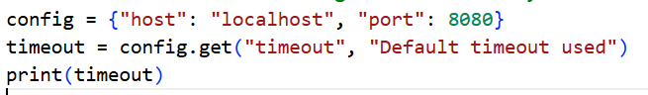
OUTPUT:
JUSTIFICATION:
In legacy code, we are using if-else conditional statement which says whether the keyword is present in the dictionary or not, whereas in new refactored code, we are using .get() which says whether the given key word is there or not, .get() works like .get(a, b), if a is true or we got any value, it prints that value, if in case we got a=Null or False(not available in dictionary) then b will be printed. This .get() is advanced version and refactored version.

TASK 04: Refactoring Conditional Logic for Scalability
PROMPT:
Refactor the above code using mapping techniques while preserving functionality which is cleaner and scalable.
CODE:
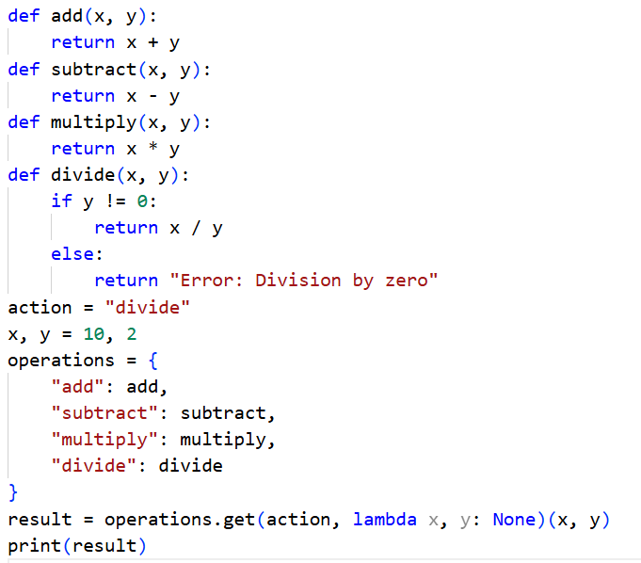
OUTPUT:
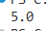
JUSTIFICATION:
In legacy code, the edge case (division by zero ) is not handled well whereas in newly refactored code we are including the edge case which smoothly handles division by zero excepional case which is most important is present life.
TASK 05: Simplifying Search Logic in Collections
PROMPT:
Refactor the logic into more concise and readable form while output behavior remains same.
CODE:
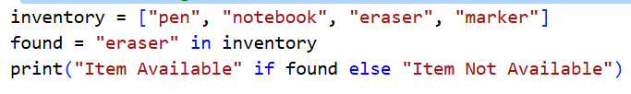
OUTPUT:
JUSTIFICATION:
In the legacy code, we are using a for loop to find whether the required item is there in our dictionary or not whereas in refactored code, we are not using any for loop to find the item in the list which reduces the time taken by the code.

